**MID-TERM PROGRESS REPORT**

**Report Name:** EasyFood

**Team Members:** Vineet Rathor (171500382), Saurabh Singh (171500302), Tarun Khandelwal (171500573)

**Introduction:**

It is known globally that, in today’s market, it is extremely difficult to start a new small-scale business and live-through the competition from the well-established and settled owners. In fast paced time of today, when everyone is squeezed for time, the majority of people are finicky when it comes to placing a food order. The customers of today are not only attracted because placing an order online is very convenient but also because they have visibility into the items offered, price and extremely simplified navigation for the order.

Online ordering system that I am proposing here, greatly simplifies the ordering process for both the customer and the restaurant. System presents an interactive and up-to-date menu with all available options in an easy to use manner. Customer can choose one or more items to place an order which will land in the Cart. Customer can view all the order details in the cart before checking out. At the end, customer gets order confirmation details. Once the order is placed it is entered in the database and retrieved in pretty much real time. This allows Restaurant Employees to quickly go through the orders as they are received and process all orders efficiently and effectively with minimal delays and confusion.

**Project Status:** On Track

**Summary:** We have made a little bit of both frontend and backend by using different technologies and once we complete the frontend then we will connect the website with the database.

**Approach:**

* Planned to discuss the overall designing of frontend.
* Created the design of the main page on paper before writing the code.
* Connected the main page with the server.
* Made the Navigation Bar
* Made the Login and Sign Up web page.
* Made the Feedback form for the website.

**Technologies Used:**

* MongoDB: MongoDB is a document database with the scalability and flexibility that you want with the querying and indexing that you need

* Express: Express.js is a Node js web application server framework, which is specifically designed for building single-page, multi-page, and hybrid web applications.
* Node js: We are using Node js as backend technology. It is an open source server environment. It uses java script on server.
* HTML :For user interfaces
* CSS : For making interfaces more attractive and stylish
* Bootstrap 4: For make website responsive.

**Modules made:**

Main Page – Made the Navigation Bar and linked the login and sign up page with the navigation bar and connected the main page with the server.

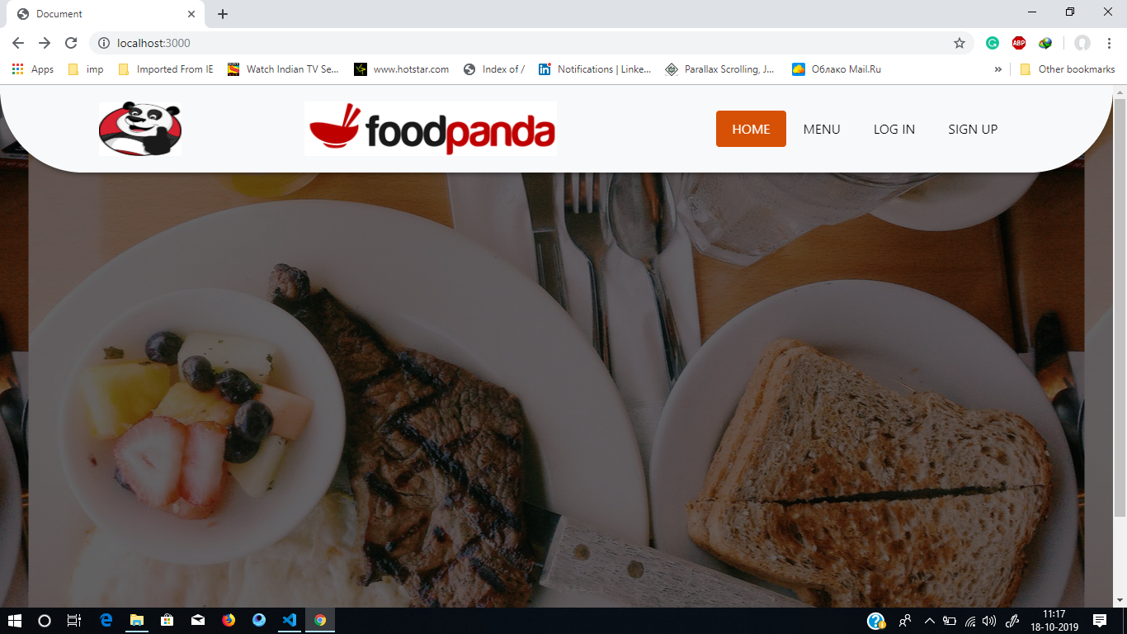

Login Page – Made the login page using HTML and CSS and has connected it to MongoDB Database.

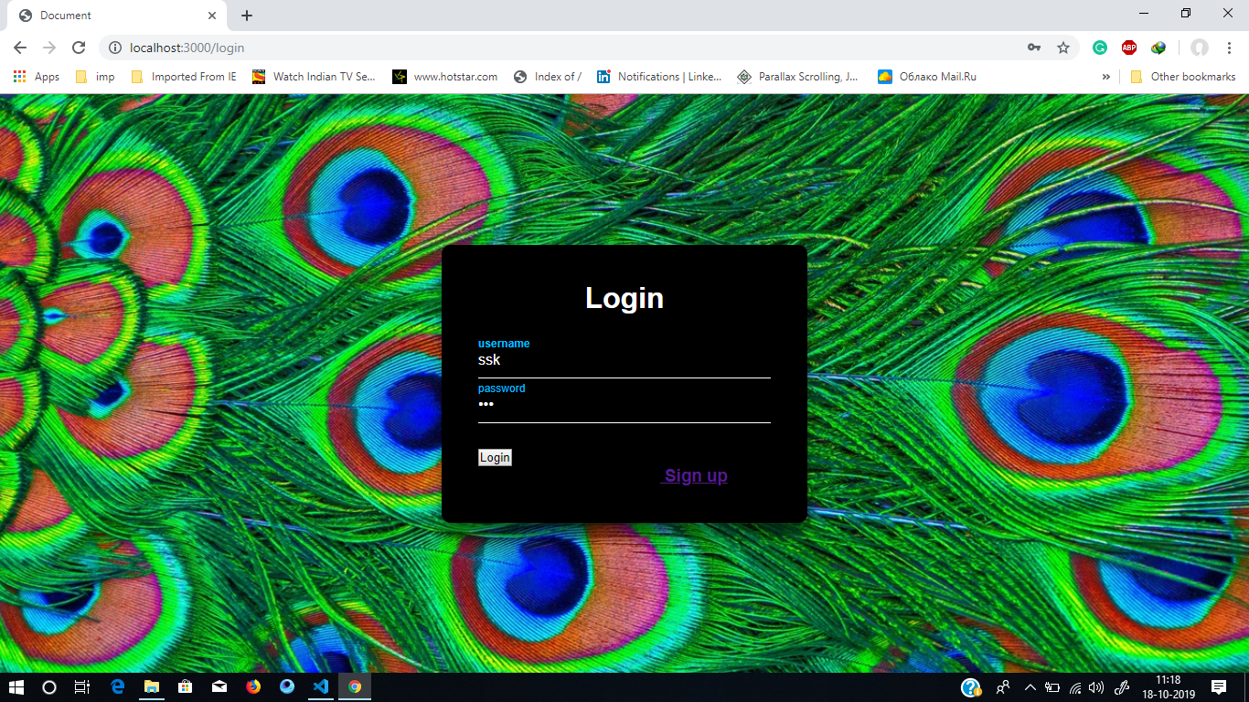

Sign Up Page: We have made the sign up page using HTML and CSS and

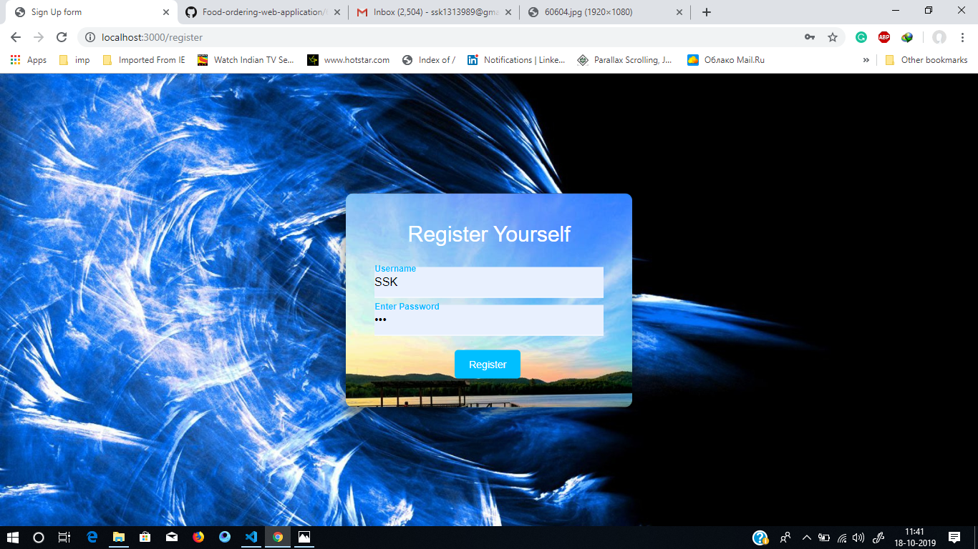

Feedback Form:

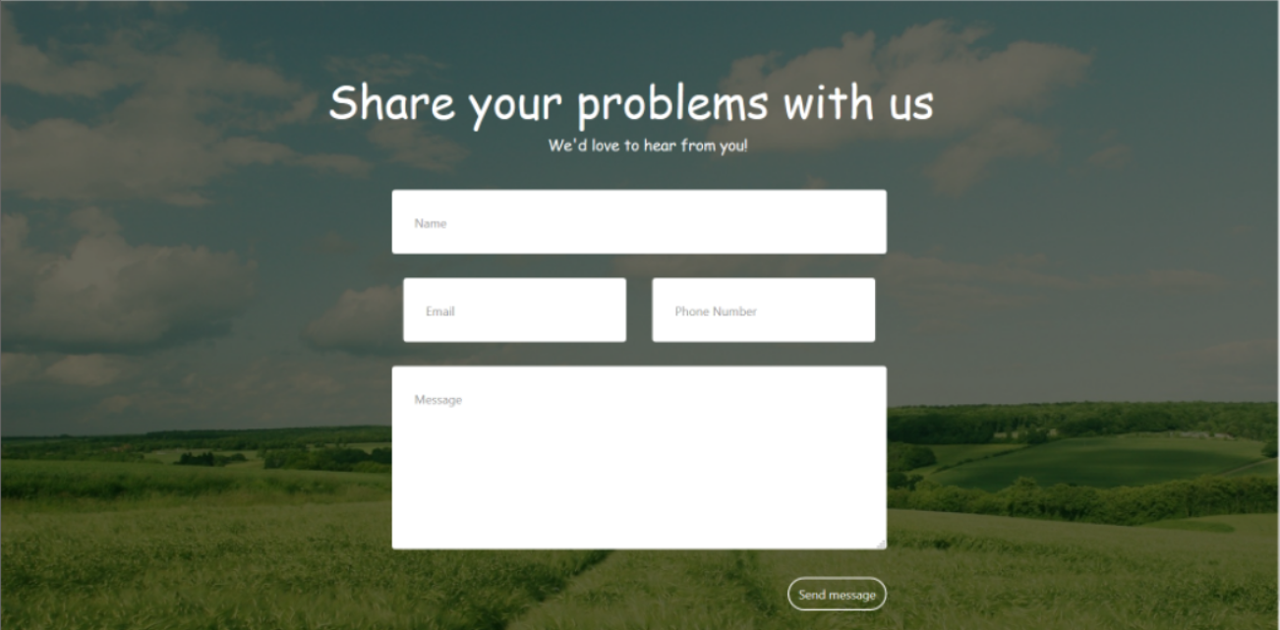

Database Value After Signup:

> use food_app

switched to db food_app

> show collections

users

> db.users.find().pretty()

{

"_id" : ObjectId("5da8d433bf08f12ed810c534"),

"username" : "SSK",

"salt" : "2662a3925bed95c663ab5ace54cf4fd303d9513fbcd0b6f6fefc84b96f8f9d2b",

"hash" : "",

"__v" : 0

}

**Challenges:** Main Challenges which we faced included:

* Thinking about different designs of the main menu and other pages of website.
* Making the design (Animations, Background slider etc) by using CSS and Html only.
* Understanding how to use Bootstrap
* Connecting with the server
* How to connect the database in the backend

**Future Planning:**

In the future we will make the customer interface i.e. details about the customer, orders placed by customer, etc. We will also improve the main web page by making the website more dynamic and adding user interactive features. We will also try to include the payment options (if possible as we are still learning full stack) and delivery options and give the option of user to make an order as a guest.